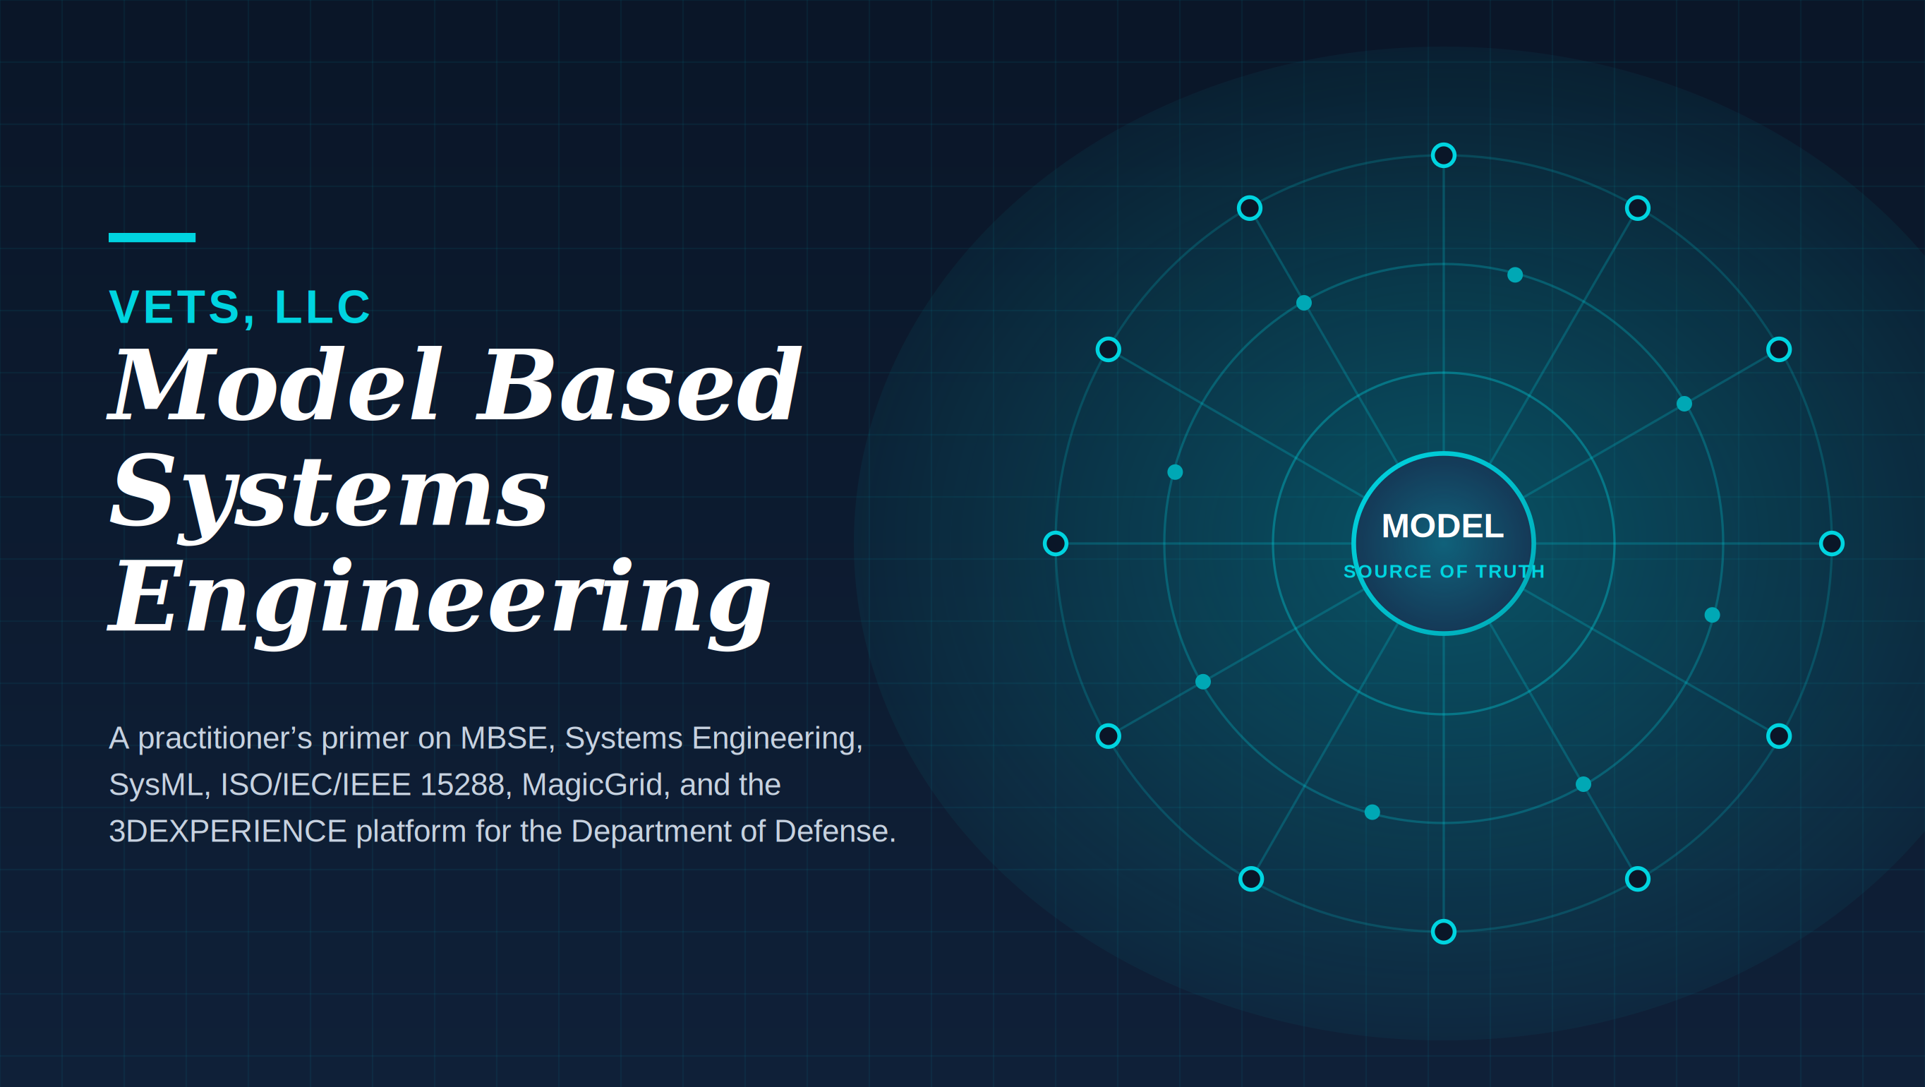

Prepared by VETS, LLC
Service-Disabled Veteran-Owned Small Business · Model Based Systems Engineering & Digital Engineering for the Department of Defense
Certified Dassault Systèmes Partner (No Magic / CATIA Magic ecosystem) · CMMC 2.0 Level 2 · AS9100 / ISO 9001 · Top Secret Facility Clearance

About This Primer
Defense systems are no longer mechanical assemblies with a little software bolted on. They are deeply interconnected, software intensive, and expected to evolve in the field for decades. Engineering them with stacks of disconnected documents simply does not hold up anymore. This primer lays out the case for Model Based Systems Engineering, or MBSE, the way VETS, LLC practices it: as the discipline that makes a single, authoritative model the source of truth for a program, from the first concept sketch through retirement.
We wrote it for program managers, government customers, and engineers who keep hearing the same handful of acronyms in every review and want a clear, plain explanation of how they fit together. By the end you should understand what MBSE is, how it differs from classical Systems Engineering, why the ISO/IEC/IEEE 15288 life cycle standard matters, where the Systems Modeling Language, SysML, and the MagicGrid method come in, and how a platform such as Dassault Systèmes 3DEXPERIENCE ties it all into one connected environment.
The shift is simple to state and hard to overstate: stop describing the system in documents about the system, and start building the system as a model.

Contents
About This Primer 2
1. What Is MBSE? 4
2. Systems Engineering vs. MBSE 4
3. Why MBSE? 5
4. Key Benefits of MBSE 5
5. MBSE in Practice 5
6. What MBSE Delivers on Real Programs 6
7. How to Get Started with MBSE 7
8. ISO/IEC/IEEE 15288 — System Life Cycle Processes 8
9. SysML — The Systems Modeling Language 10
10. MagicGrid — A Method for Building the Model 10
11. What a Systems Engineering Platform Must Do 12
12. Systems Engineering on the 3DEXPERIENCE Platform 13
13. How VETS, LLC Delivers 13
Appendix A. Acronyms and Abbreviations 15

1. What Is MBSE?
Model Based Systems Engineering is the formalized use of models to support the specification, design, analysis, verification, and validation of complex systems. Rather than scattering system knowledge across requirements documents, interface specs, slide decks, and spreadsheets, MBSE captures it once, in a connected model that everyone works from. The model becomes the central source of truth for the entire life cycle.
The International Council on Systems Engineering (INCOSE) popularized the term and frames it as the formalized application of modeling that supports requirements, design, analysis, verification, and validation, beginning in the conceptual phase and continuing through development and the later life cycle stages. In plain terms: model early, model continuously, and let the model carry the program.

2. Systems Engineering vs. MBSE
It is easy to blur these two together, so it is worth pinning down the distinction. Systems Engineering, SE, is the interdisciplinary discipline of designing, integrating, and managing complex systems across their whole life. It balances the technical and the nontechnical, requirements, architecture, verification, cost, schedule, risk, and supportability, so the delivered system actually meets stakeholder needs and mission objectives. SE is about clear stakeholders, traceable requirements, and disciplined process from concept through retirement.
MBSE is the practice of carrying out those same SE activities using formalized digital models instead of static documents. Requirements capture, architecture definition, behavior specification, analysis, and verification all live in an integrated model. That model removes ambiguity, enables automated traceability, and supports simulation and early validation so teams catch problems while they are still cheap to fix.
The cleanest way to hold the two apart in your head is this. Systems Engineering is the process and the objectives — the what and the why. MBSE is the method and the tooling that make that process efficient, repeatable, and auditable — the how. Together they cut risk and rework, sharpen collaboration across disciplines, and lay the groundwork for the Digital Thread and the Digital Twin.
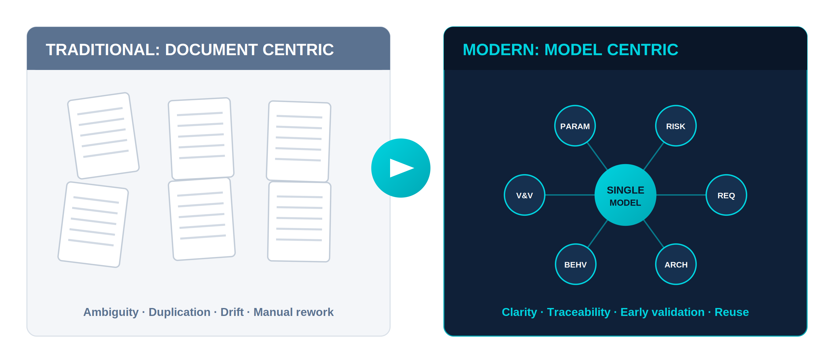
Figure 1. The shift from a document centric to a model centric practice.

3. Why MBSE?
Modern systems are complex, interconnected, and software driven, and traditional document centric methods buckle under that weight. The usual symptoms are familiar to anyone who has lived through a large program:
- Requirements that are ambiguous and get interpreted three different ways by three different teams.
- Redundant and inconsistent information spread across documents that quietly fall out of sync.
- Changes that are nearly impossible to trace cleanly across life cycle stages.
MBSE answers all three with a single, shared, model based representation. One change propagates everywhere it touches. Collaboration improves, errors drop, and the program gains genuine digital continuity instead of a paper trail that has to be reconciled by hand.

4. Key Benefits of MBSE
- Clearer communication. Models give everyone a visual, unambiguous picture of requirements, functions, architecture, and behavior.
- Traceability. Requirements, design elements, test cases, and verification activities are directly linked, so nothing falls through the cracks.
- Consistency and accuracy. A single source of truth eliminates the duplication and mismatch that plague document sets.
- Early validation. Simulation and model analysis surface problems early, when they cost a fraction of what a late fix costs.
- Scalability. The approach handles complex, multidomain systems without collapsing under its own paperwork.
- A foundation for Digital Engineering. MBSE is the bedrock the Digital Twin and Digital Thread are built on.

5. MBSE in Practice
In everyday work, MBSE uses SysML and supporting modeling tools to represent the system as a set of connected artifacts:
- Requirements models — that capture stakeholder needs.
- Functional models — that describe what the system does and how it behaves.
- Logical and physical architecture models — that represent structure and design alternatives.
- Verification and validation models — that prove the requirements are satisfied.
These artifacts span the life cycle phases defined by ISO/IEC/IEEE 15288 — Concept, Development, Production, Utilization, Support, and Retirement — so the model grows with the program rather than being thrown away at each gate.

6. What MBSE Delivers on Real Programs
Adopting MBSE on an actual program pays off across quality, efficiency, risk, and collaboration. The benefits are concrete:
- Managing complexity and integration. A unified model integrates requirements, architecture, and behavior across every subsystem — avionics, propulsion, guidance, safety — letting engineers reason at the system level and the detail level at the same time.
- Traceability and risk mitigation. End to end links between requirements, design decisions, and verification make compliance demonstrable and gaps visible early. Coupled with simulation, that catches design issues before the expensive phases such as integration and operations.
- Collaboration and communication. The model is a shared, semantic lingua franca across engineering disciplines, nonengineering stakeholders, and the supply chain. Changes propagate instantly, which heads off misunderstanding and rework.
- Cost, schedule, and resource efficiency. Virtual prototyping avoids physical iteration and costly late stage surprises, protecting both budget and timeline while automating routine work.
- Verification, validation, and reuse. Test cases and requirements are linked dynamically, simplifying audit and compliance, while proven model components are standardized and reused across derivative programs.
- Support for digital transformation. MBSE underpins digital twins, digital threads, and enterprise wide digital engineering, linking every step from early design through manufacturing and sustainment.
In short, MBSE makes programs better at managing risk, more efficient, better coordinated, and more adaptable — which is exactly why it has become indispensable for organizations competing in this space.
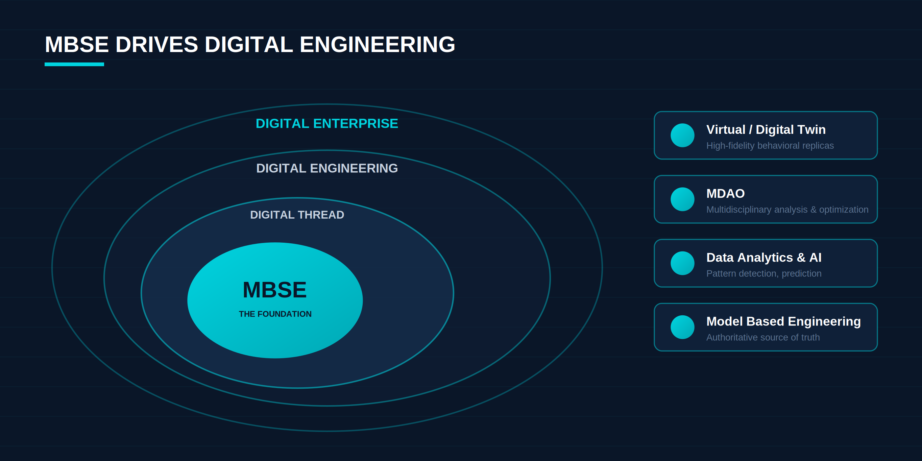
Figure 2. MBSE sits at the core. Everything in Digital Engineering builds outward from it.

7. How to Get Started with MBSE
A common mistake is to open a modeling tool on day one and start drawing diagrams without understanding the engineering process underneath. That gets the order backwards. Here is the sequence VETS recommends.

Understand the difference between the SE process and MBSE first
SE is the product life cycle and the development process. MBSE is the means of capturing that process with the help of tools and languages such as SysML. They are related but not the same, and you want a solid grasp of the SE process before you pick up the tooling. Skip this step and SysML will feel arbitrary and needlessly complex.

Start with the V-Model
The V-Model is the friendliest entry point. It lays the development process out in plain steps — capture requirements, define architecture, implement, then verify and validate — and it applies whether the system is mechanical, electrical, electronic, or software.

Map the V-Model onto the 15288 technical processes
Once the V-Model is second nature, map it onto the 15288 technical processes. They line up closely. Business or Mission Analysis, Stakeholder Needs and Requirements Definition, and System Requirements Definition all map to the requirements arm of the V. The 15288 standard simply goes deeper inside each step — stakeholder identification, use case definition, validation criteria, and so on. The rest of the V maps to the remaining 15288 workflows the same way.
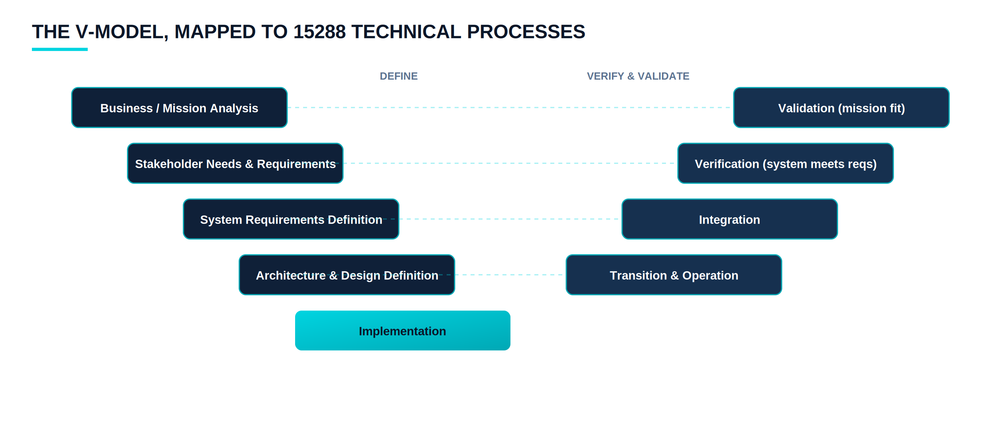
Figure 3. The V-Model definition arm and verification arm, mapped to 15288 technical processes.
A word of caution is in order here. The V-Model is focused on the technical side of development. The full 15288 process also covers project management, risk management, configuration and issue management, quality, and resource planning. When you move into MBSE, keep the nontechnical processes in view too. If you are brand new to this, get comfortable with the technical aspects first, then widen out.

Introduce SysML
With the process understood, SysML is how you capture it. It gives you everything a development effort needs to express: requirement elicitation, stakeholder identification, use case and test case definition, early collaboration, risk mitigation, trade off analysis, architecture definition, and verification. The syntax can look intimidating at first, but the payoff is large — provided you came in with the process understanding from the earlier steps.

Connect SysML to the rest of the toolchain
Finally, connect the information captured in the SysML model to the wider engineering ecosystem — Product Lifecycle Management (PLM) for mechanical design, Application Lifecycle Management (ALM) for software, and so on. The goal is traceability across the whole development process, which is best achieved on an integrated platform where those disciplines converge. The 3DEXPERIENCE platform is one of the strongest examples of that integrated approach, covered in Section 14.

8. ISO/IEC/IEEE 15288 — System Life Cycle Processes
ISO/IEC/IEEE 15288 defines a common framework of processes for the entire life of a system, from the first idea through retirement. It gives organizations a shared language and structure for planning, developing, operating, maintaining, and disposing of systems in a consistent, disciplined way. The standard groups its processes into four broad categories:
- Agreement processes — cover acquisition and supply, making sure contractual and stakeholder commitments are handled.
- Organizational project enabling processes — establish the structures, resources, and improvements that let projects succeed.
- Technical management processes — plan, monitor, assess, and control the project — including risk, configuration, and quality management.
- Technical processes — are the engineering activities that actually realize the system: requirements definition, architecture, integration, verification, validation, transition, operation, maintenance, and disposal.
Taken together, these processes enforce a life cycle perspective: systems are conceived, built, used, supported, and ultimately retired in a structured and traceable manner. Adopting 15288 gives an organization a holistic framework that improves consistency and cross discipline collaboration while balancing performance, cost, schedule, and risk.

8.1 Life Cycle Stages
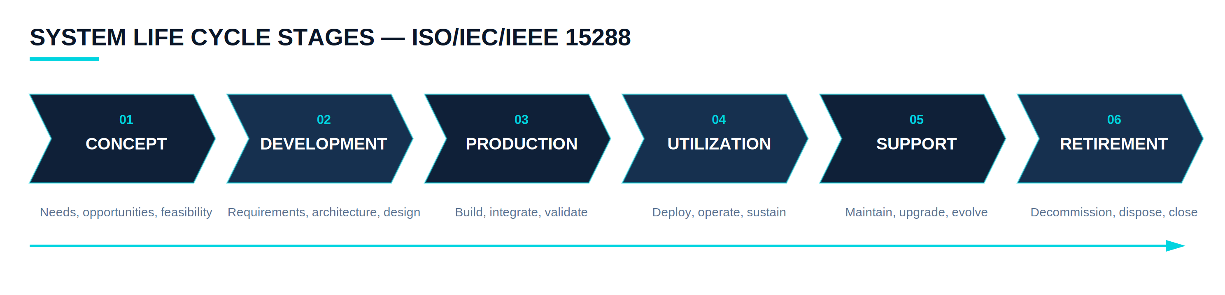
Figure 4. The six 15288 life cycle stages.
- Concept — identifying needs, opportunities, and feasibility.
- Development — defining requirements, architecture, design, and realization.
- Production — building, integrating, and validating the system.
- Utilization — deploying, operating, and supporting the system in service.
- Support — maintenance, logistics, upgrades, and evolution.
- Retirement — decommissioning, disposal, and closure.

8.2 Purpose and Application
15288 gives systems engineers and project teams a common process language and reference that improves communication, coordination, and consistency. It applies to a wide range of human made systems — hardware, software, data, procedures, and facilities — and flexes to fit different levels of complexity and scale.

8.3 Structure and Benefits
Following the 15288 processes ensures comprehensive coverage of the life cycle, from defining stakeholder needs to system disposal, while improving quality, risk management, and project control. It also smooths supplier and acquirer coordination and supports iterative, concurrent application of processes where that makes sense. In short, it is the foundational standard for establishing rigorous, globally recognized life cycle processes that deliver reliable, well managed systems.

9. SysML — The Systems Modeling Language
SysML is a standardized graphical modeling language built to support MBSE. It lets engineers analyze, design, and manage complex systems by representing their requirements, behavior, structure, and relationships in a consistent, visual way. It extends and adapts the Unified Modeling Language (UML) for systems engineering, so it covers not just software but hardware, processes, people, and facilities.
SysML organizes its diagrams into four working families:
- Requirements diagrams — capture and relate stakeholder and system requirements.
- Behavior diagrams — describe what the system does — use case, activity, sequence, and state machine diagrams.
- Structure diagrams — define the architecture — block definition and internal block diagrams.
- Parametric diagrams — capture constraints and performance relationships, which makes them powerful for analysis and trade studies.
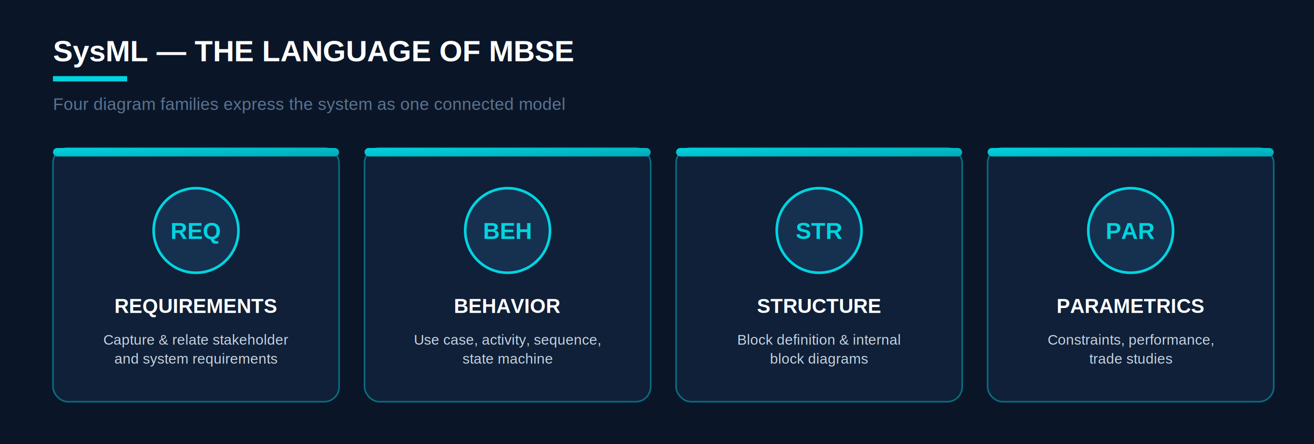
Figure 5. The four SysML diagram families, expressing one connected model.
In practice SysML does three things exceptionally well: it bridges communication between multidisciplinary teams, it preserves traceability from stakeholder needs all the way to design and verification, and it enables consistent, model driven development across the life cycle.

9.1 How SysML and MBSE Relate
These two travel together but play different roles. MBSE is the methodology — the model centric way of doing systems engineering. SysML is the language that methodology speaks. Put simply, MBSE is the approach, the way systems get engineered using models, and SysML is the toolset, the way those models are expressed and communicated. Used together, they make engineering information model driven, connected, and analyzable, which is what produces better, more reliable, more efficient systems.

10. MagicGrid — A Method for Building the Model
Knowing SysML is not the same as knowing how to build a good model with it. That is the gap MagicGrid fills. It is a structured MBSE framework that organizes SysML models and aligns them with the systems engineering process defined by 15288. It uses a matrix, or grid, to capture and relate information across abstraction levels — from stakeholder needs down through system requirements, logical design, and physical realization — while keeping everything consistent, traceable, and complete.
MagicGrid is organized into domains (what, how, why) and levels (problem, solution):
- Problem domain — focuses on what needs to be solved — capturing stakeholder needs and defining system requirements (the black box view).
- Solution domain — focuses on how the system will solve it — developing the logical and physical architectures (the white box view).
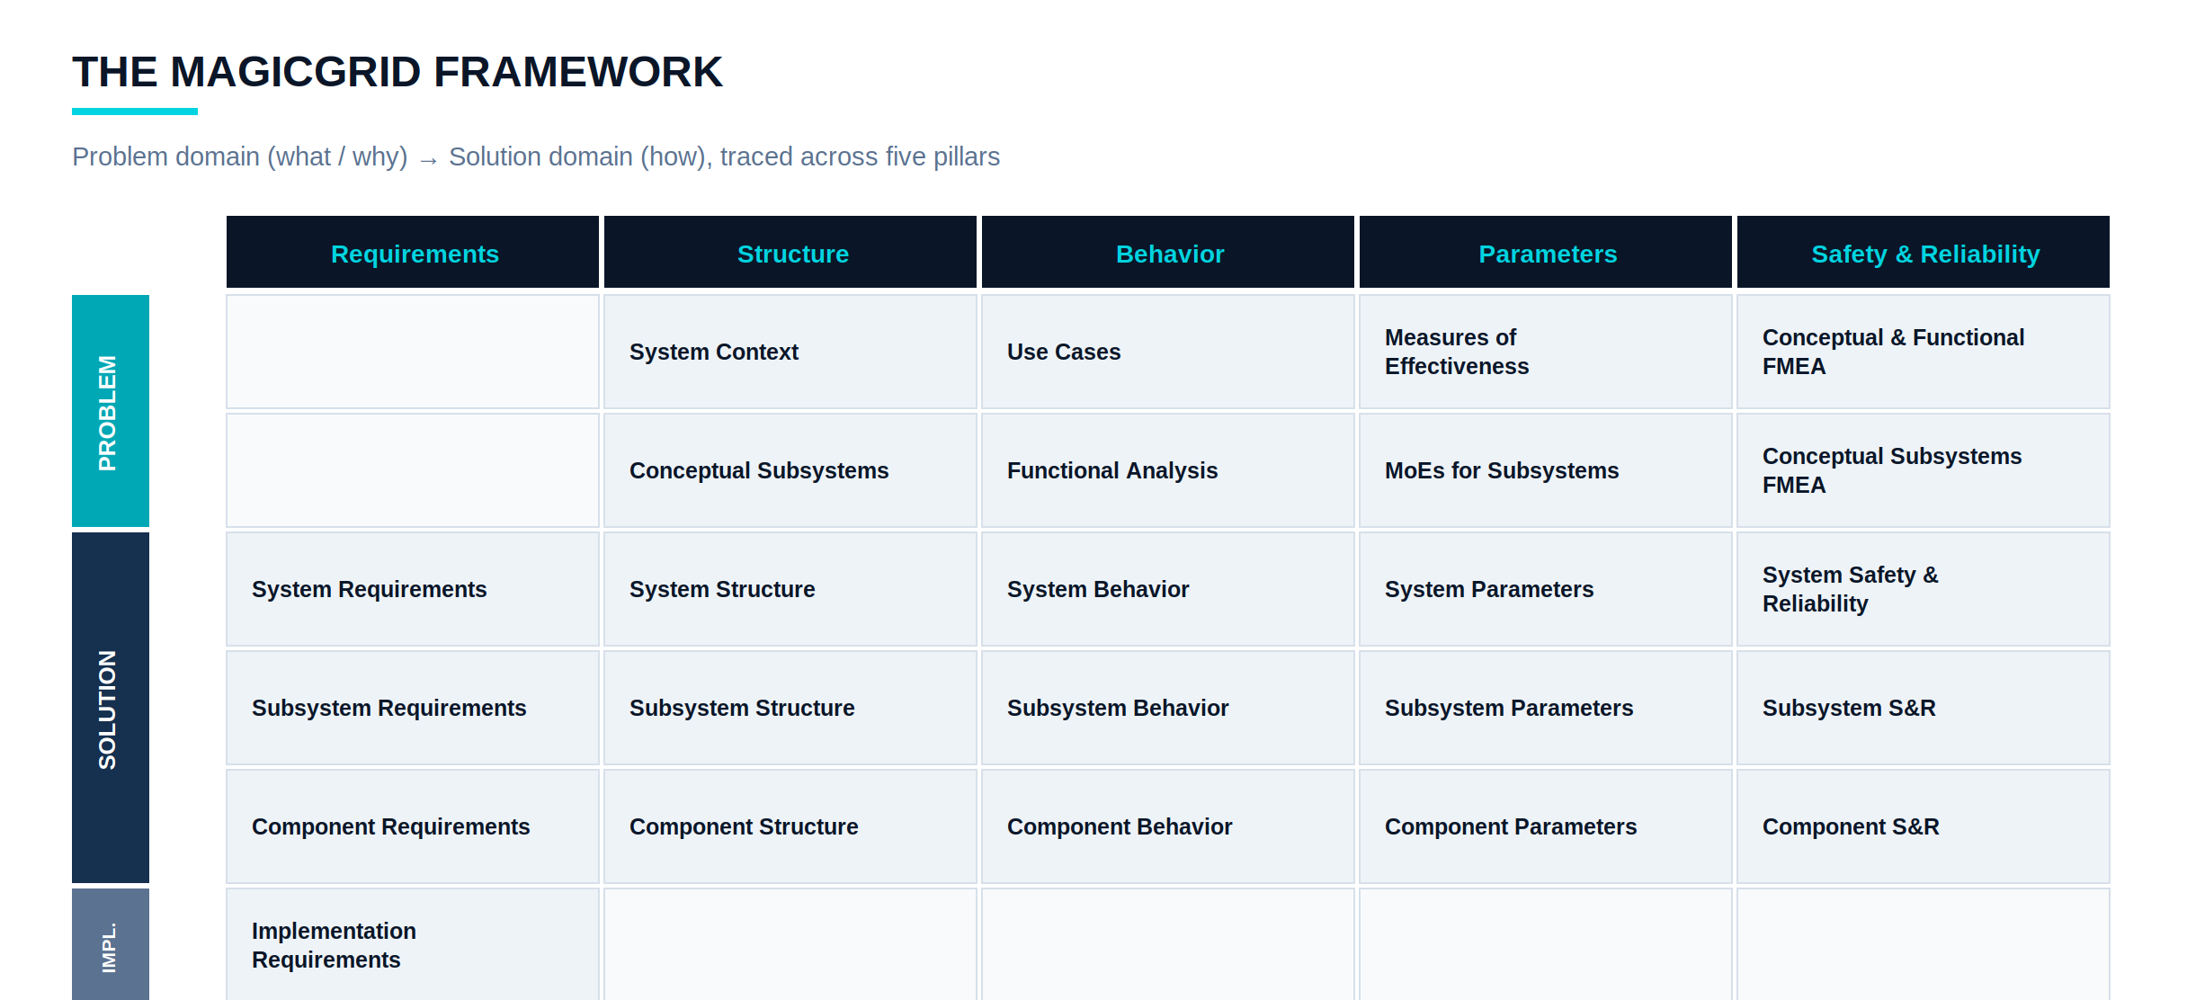
Figure 6. The MagicGrid framework: domains and levels mapped across five engineering pillars.
Working through the grid, engineers keep clear traceability from needs to design to verification, stay aligned with MBSE and SysML practice, and maintain structured communication and model consistency across every life cycle stage. It is the bridge from stakeholder intent to system realization.

10.1 Why MagicGrid
MagicGrid brings the three core MBSE ingredients — method, language, and modeling tool — together in one practical package. It grew out of real adoption projects across defense, aerospace, automotive, and healthcare, where teams needed an unambiguous way to build SysML models and found the existing methods too abstract for real problems. It is practical for three reasons: it works with plain, “vanilla” SysML and needs no custom extensions; it clearly defines a modeling process grounded in systems engineering best practice; and it is tool independent, so long as the tool supports SysML.

10.2 MagicGrid and 15288 Working Together
These two are complementary. 15288 defines the processes and the life cycle stages. It specifies what activities to perform but not how to implement them. MagicGrid supplies the how. It organizes SysML artifacts to implement those processes inside an MBSE environment, mapping each activity — stakeholder needs definition, requirements analysis, architecture design, verification — to specific SysML diagrams and model elements. The result is development that is both process driven, per 15288, and model based, per MagicGrid: consistent, traceable, and analyzable from stakeholder needs to system realization.

11. What a Systems Engineering Platform Must Do
A capable SE platform provides an integrated, model based environment spanning the full life cycle, from capturing stakeholder needs to final verification and validation. For defense and aerospace work it must align with the key standards — ISO/IEC 15288, ARP4754A, ARP4761, DO-178C, and DO-254 — so every stage follows a rigorous, traceable, certifiable process. The capabilities that matter:
- Requirements management — to capture, organize, and trace stakeholder, system, and derived requirements across the life cycle, tightly integrated with the SysML model and backed by strong configuration and change control.
- Modeling and architecture definition — supporting functional and physical decomposition, black box and white box analysis, behavior modeling, and interface management through Interface Control Documents (ICDs).
- Integration with domain tools — such as CATIA for mechanical design, Capital or E3.series for electrical, and MATLAB/Simulink or SCADE for software, plus simulation environments like Modelica, Dymola, or Amesim for behavior and performance analysis.
- Safety, reliability, and certification support — with FMEA, FMECA, and fault tree analysis (FTA), hazard tracking, and compliance management aligned to ARP4754A, ARP4761, and DO-178C/DO-254.
- Lifecycle management and collaboration — integrating PLM and ALM, with built in change workflows, version control, and role based access for globally distributed teams.
- Digital continuity — through a digital thread that connects all life cycle data and a digital twin that links the model to real world operational data for monitoring, predictive maintenance, and optimization.
- A robust, scalable architecture — with a centralized model repository, open standard interoperability (SysML, STEP, ReqIF, FMI/FMU), cloud deployment, and cybersecurity and ITAR compliant safeguards — the kind of posture VETS maintains with CMMC 2.0 Level 2 and a Top Secret Facility Clearance.
- Advanced analysis — for trade studies, optimization, and mission analysis, increasingly augmented by AI and machine learning for pattern recognition, anomaly detection, and closed loop life cycle feedback.
Solutions such as Dassault Systèmes 3DEXPERIENCE exemplify this kind of environment, delivering digital continuity, multidisciplinary integration, and compliance with development standards in one place.

12. Systems Engineering on the 3DEXPERIENCE Platform
The 3DEXPERIENCE platform for Systems Engineering delivers an integrated MBSE development environment with discipline specific capabilities that accelerate the development and validation of complex products and their embedded systems. Built on a common, consistent set of system models, it transforms the development process by integrating every engineering discipline, and it adapts to complement tools and processes a program already has in place.
As a certified Dassault Systèmes partner working in the No Magic / CATIA Magic ecosystem, VETS builds and runs these environments for DoD programs. On the platform, Systems Engineering enables:
- MBSE with CATIA Magic — (formerly Cameo Systems Modeler), with full support for SysML and the MagicGrid framework.
- End to end traceability — from requirements to system architecture to design to simulation to validation.
- Cross domain collaboration — across mechanical, electrical, software, and manufacturing, all on a single digital thread.
- Standards alignment — with ISO/IEC/IEEE 15288, ensuring process compliance and life cycle consistency.

12.1 Key Features and Benefits
- Integrated, unified environment. A common database connects every stakeholder and discipline, creating one source of truth for all project data.
- Model based systems engineering. A model based approach defines functional and logical architectures with traceability from requirements through design and verification.
- Virtual twin experience. High fidelity digital replicas let teams simulate, test, and predict system behavior, surfacing issues and optimizing designs early.
- Multidisciplinary collaboration. Mechanical, electrical, fluidics, and software engineers work together inside the platform, keeping components aligned and reducing integration risk.
- Traceability. End to end links from requirements to design decisions, simulations, and tests manage complexity and demonstrate compliance.
- Cloud based platform. Cloud availability frees teams from local IT constraints and enables real time access to project data and intelligence.

13. How VETS, LLC Delivers
VETS, LLC is a Service-Disabled Veteran-Owned Small Business focused on MBSE and Digital Engineering for the Department of Defense. We take the concepts in this primer and put them to work on programs that demand rigor, security, and traceability. Our delivery follows a straightforward arc — capture, architect, analyze, deliver — anchored in the MagicGrid method and executed on the 3DEXPERIENCE platform.
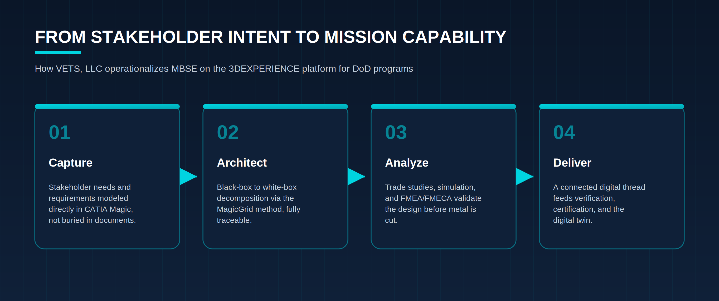
Figure 7. The VETS delivery model, from stakeholder intent to fielded mission capability.
Behind that delivery sits the posture defense customers need: a Top Secret Facility Clearance, CMMC 2.0 Level 2 certification, AS9100 and ISO 9001 quality systems, and certified Dassault Systèmes partnership in the No Magic / CATIA Magic ecosystem. VETS also produces AxonDE, a GenAI-powered MBSE tool aimed at DoD programs that must implement MBSE under DoD Instruction 5000.97, bringing the speed of generative AI to the disciplined, traceable practice this primer describes.
Model based engineering is no longer optional for serious defense programs. The question is not whether to adopt it, but how quickly and how well. That is the work VETS does.

Appendix A. Acronyms and Abbreviations
Acronym | Definition
ALM | Application Lifecycle Management
AI | Artificial Intelligence
ARP4754A | SAE Aerospace Recommended Practice — Guidelines for Development of Civil Aircraft and Systems
ARP4761 | SAE Aerospace Recommended Practice — Safety Assessment Process
AS9100 | Aerospace Quality Management System Standard
CAD | Computer-Aided Design
CAGE | Commercial and Government Entity (Code)
CMMC | Cybersecurity Maturity Model Certification
DE | Digital Engineering
DO-178C | Software Considerations in Airborne Systems and Equipment Certification
DO-254 | Design Assurance Guidance for Airborne Electronic Hardware
DoD | Department of Defense
DoDI | Department of Defense Instruction
FMEA | Failure Mode and Effects Analysis
FMECA | Failure Mode, Effects, and Criticality Analysis
FMI/FMU | Functional Mock-up Interface / Functional Mock-up Unit
FTA | Fault Tree Analysis
GenAI | Generative Artificial Intelligence
ICD | Interface Control Document
INCOSE | International Council on Systems Engineering
ISO/IEC/IEEE | International Organization for Standardization / International Electrotechnical Commission / Institute of Electrical and Electronics Engineers
ITAR | International Traffic in Arms Regulations
MBSE | Model Based Systems Engineering
MDAO | Multidisciplinary Analysis and Optimization
MoE | Measure of Effectiveness
PLM | Product Lifecycle Management
ReqIF | Requirements Interchange Format
S&R | Safety and Reliability
SDVOSB | Service-Disabled Veteran-Owned Small Business
SE | Systems Engineering
STEP | Standard for the Exchange of Product Model Data (ISO 10303)
SysML | Systems Modeling Language
UEI | Unique Entity Identifier
UML | Unified Modeling Language
V&V | Verification and Validation
© VETS, LLC. This primer is provided for educational and informational purposes. Standards, products, and third party platforms referenced herein are the property of their respective owners.

